MATHS MISSION
Water Guardians
🎯 YOUR ROLE: JUNIOR WATER MONITOR
📋 Your Mission
Your school built a new water tank. 💧 It gives water to the garden, where everyone grows food and plants.
Every day, rain adds water and the sun takes some away.
Big question: will there be enough water — 200 litres — by Day 5? You're the Junior Water Monitor. Let's find out.
💭 Before You Begin
- Why do plants need water to grow?
- What could happen if a water tank runs low?
🗣️ Talk with a partner about a growing pattern you've noticed.
📖 Background
Communities look after their water carefully — a tank, dam, bore, or river can run low. Watching the numbers helps people plan ahead.
🔍 Step 1 – Find the Important Numbers
Read the story below. Circle the numbers as you find them.
The tank starts with 130 litres. Every day, rain adds 20 litres and the sun takes away 5 litres. The garden needs 200 litres by Day 5.
- Added each day: ____
- Taken away each day: ____
✏️ Step 2 – Fill In the Table
Day 0 and Day 1 are done for you: 130 + 20 − 5 = 145.
Use the same idea to fill in Day 2 to Day 5.

Day | Water in the Tank
0 | 130 L (the start)
1 | 145 L
2 | ____
3 | ____
4 | ____
5 | ____

📍 Step 3 – What Does a Point Mean?
A point on a graph is written like this: (Day, Litres).
For example, (0, 130) means — Day 0, 130 litres. That's the start.
What do you think (1, 145) means?: ____________________________
📈 Step 4 – Plot Your Graph
The points (0, 130) and (1, 145) are already plotted below. The bottom axis shows the Day. The side axis shows the Litres.
Use your table to plot Day 2 to Day 5. Then join all the dots with a line.
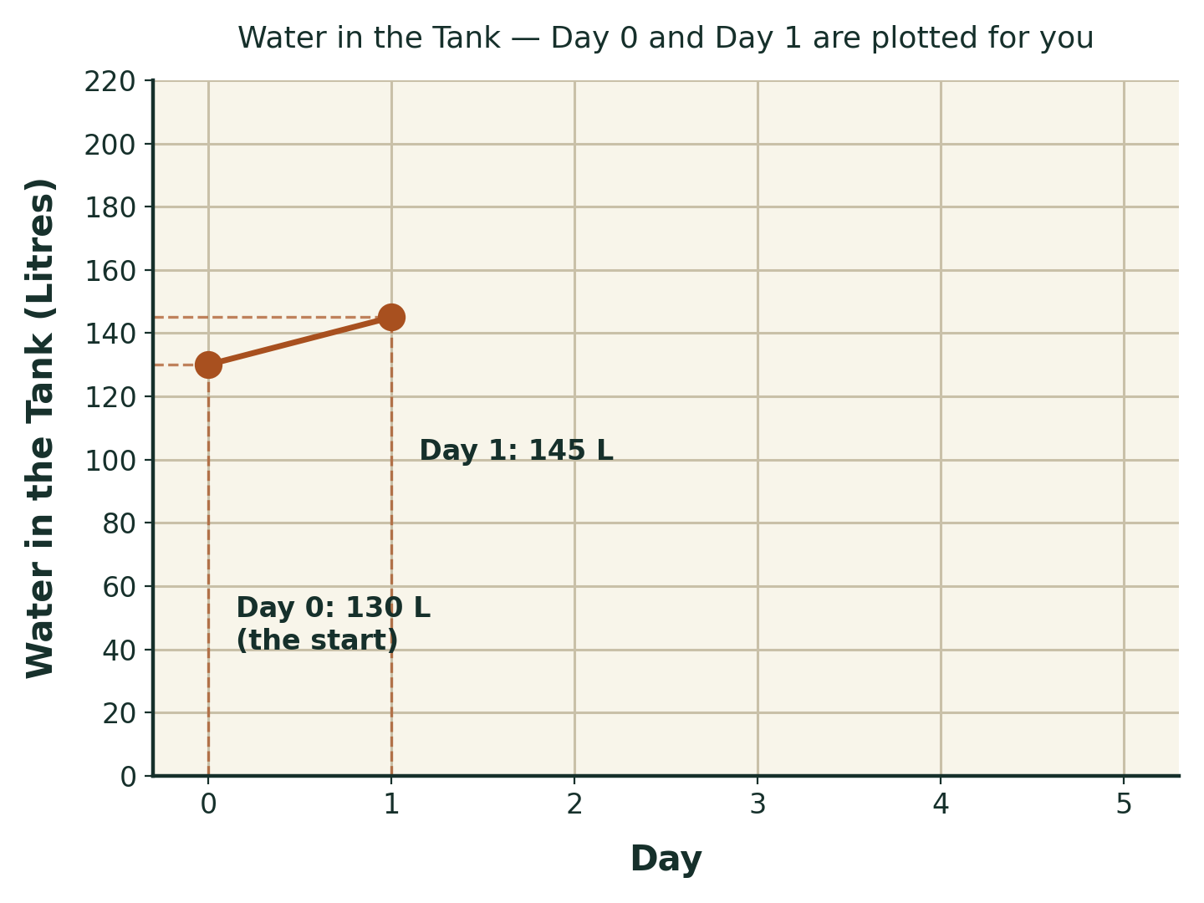
- How much does the water go up by, each day?
🗣️ Compare your table with a partner. Did you get the same numbers?
🧠 Make a Decision
By Day 5, will there be enough water — 200 litres — for the garden?
☐ Yes
☐ No
Prove it using your table or graph.
: ____________________________________________________________
: ____________________________________________________________
⚠️ Mission Challenge
This week, it doesn't rain on Day 2 or Day 3. The sun still takes 5 litres those days.
Fill in the new table below.

Day | Water in Tank
0 | 130 L
1 | ____
2 | ____ (no rain)
3 | ____ (no rain)
4 | ____
5 | ____
Is there still enough water by Day 5? Has your answer changed?
: ____________________________________________________________
⭐ Extension Challenge
This graph has a dashed line drawn across it.
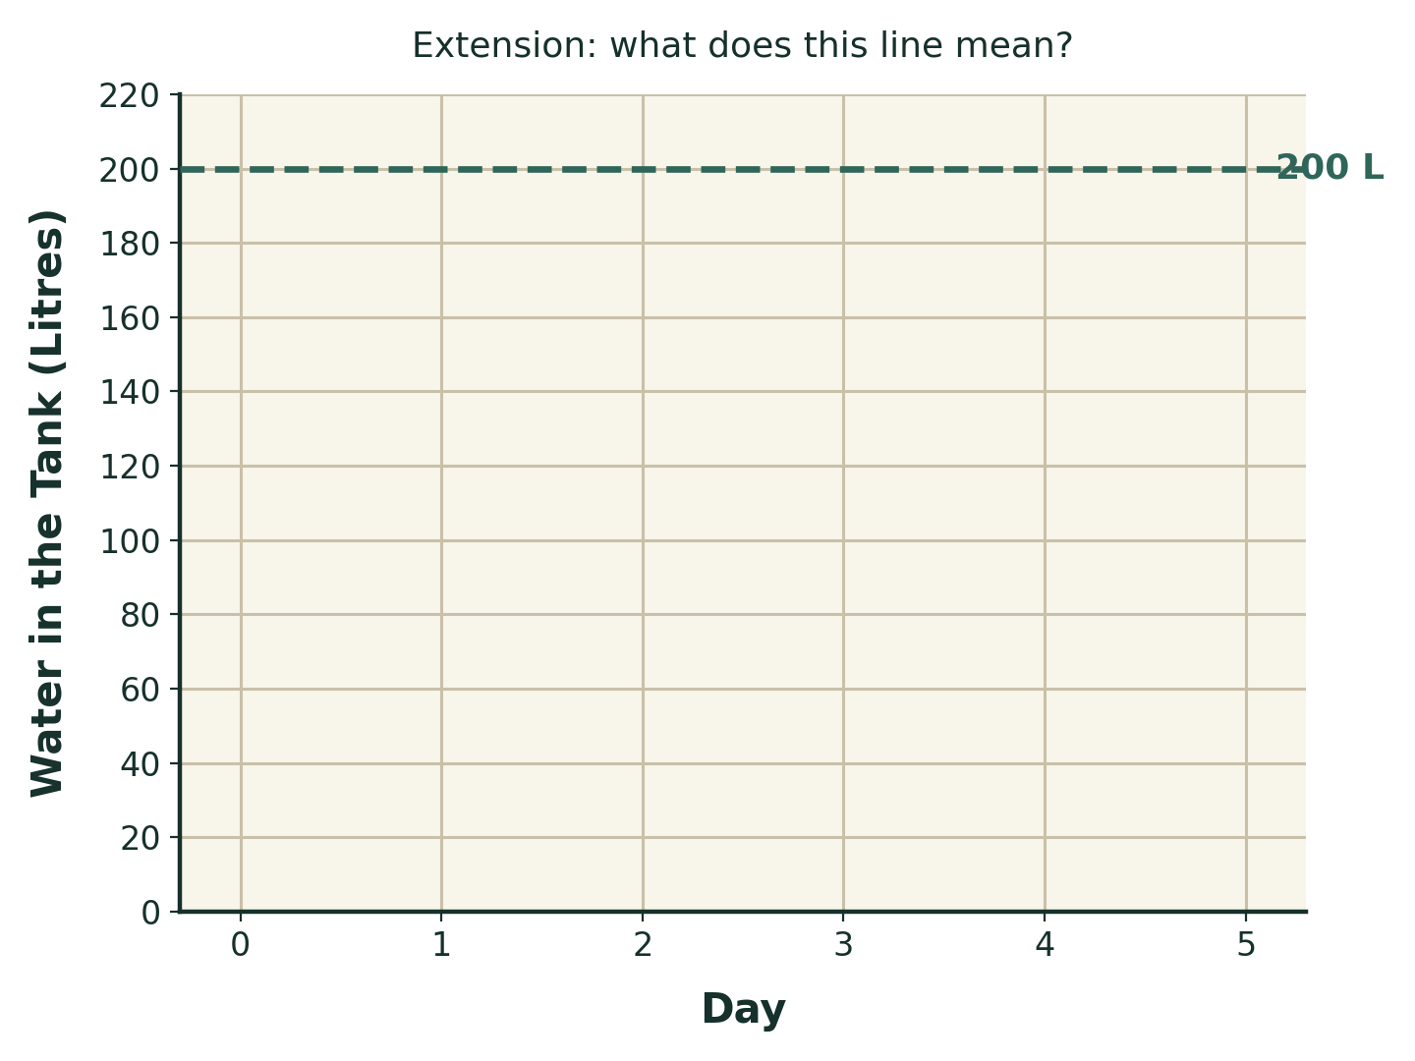
What do you think this line means?
🗣️ Talk with a partner about your pattern before you write it down.
My idea: __________________________________________________
Now plot your Mission Challenge points on this graph. Are they above the line, or below it?
: ____________________________________________________________
🌏 Community Connection
Water matters everywhere. Think about where your community gets water.
- A tank
- A river or creek
- A dam or wetland
Why is it important to know how much water is there?
: ____________________________________________________________
💬 Reflection
Circle how you felt about today's mission:
😀 Confident 🙂 Mostly understood 😐 Needed some help 😕 Found it difficult
What was the best part of being a Water Monitor today?
: ____________________________________________________________
🌟 Bonus Challenge
You're the Water Manager now! Write one tip for saving water at school.
: ____________________________________________________________
: ____________________________________________________________

