MATHS MISSION
Power Planner
🎯 YOUR ROLE: ENERGY PLANNER
📋 Your Mission
The school hall has a high power bill. You've been asked to investigate whether installing solar panels would actually save money over time — and if so, how long it would take to pay off.
💭 Before You Begin
- Why might something with a big upfront cost still be a good investment?
- What information would you need before recommending a big purchase like this?
🗣️ Talk with a partner: is solar worth it? What's your first guess?
📖 Background
Solar power is increasingly common on remote buildings. While panels cost money upfront, they can reduce ongoing running costs significantly — but it takes time before the savings outweigh the initial cost.
💡 Step 1 – Monthly Savings
Current bill: $240 per month. Estimated bill after solar: $60 per month.
Work out the monthly saving, then express it as a percentage of the original bill.
- Monthly saving = $240 − $60 = $____
- Percentage saved = (saving ÷ $240) × 100 = ____%
📍 Step 2 – What Does a Point Mean?
A point on this graph is written like this: (Month, Total Cost So Far).
(0, 3600) means — Month 0, total cost so far is $3600 for the Solar option. That's just the installation, before any bills.
What do you think (0, 0) means for the No Solar option?: ____________________________
📈 Step 3 – Read the Break-Even Graph
Below is a graph of both options over 24 months. The bottom axis shows the Month. The side axis shows the Total Cost So Far.
Find the point where the two lines cross.
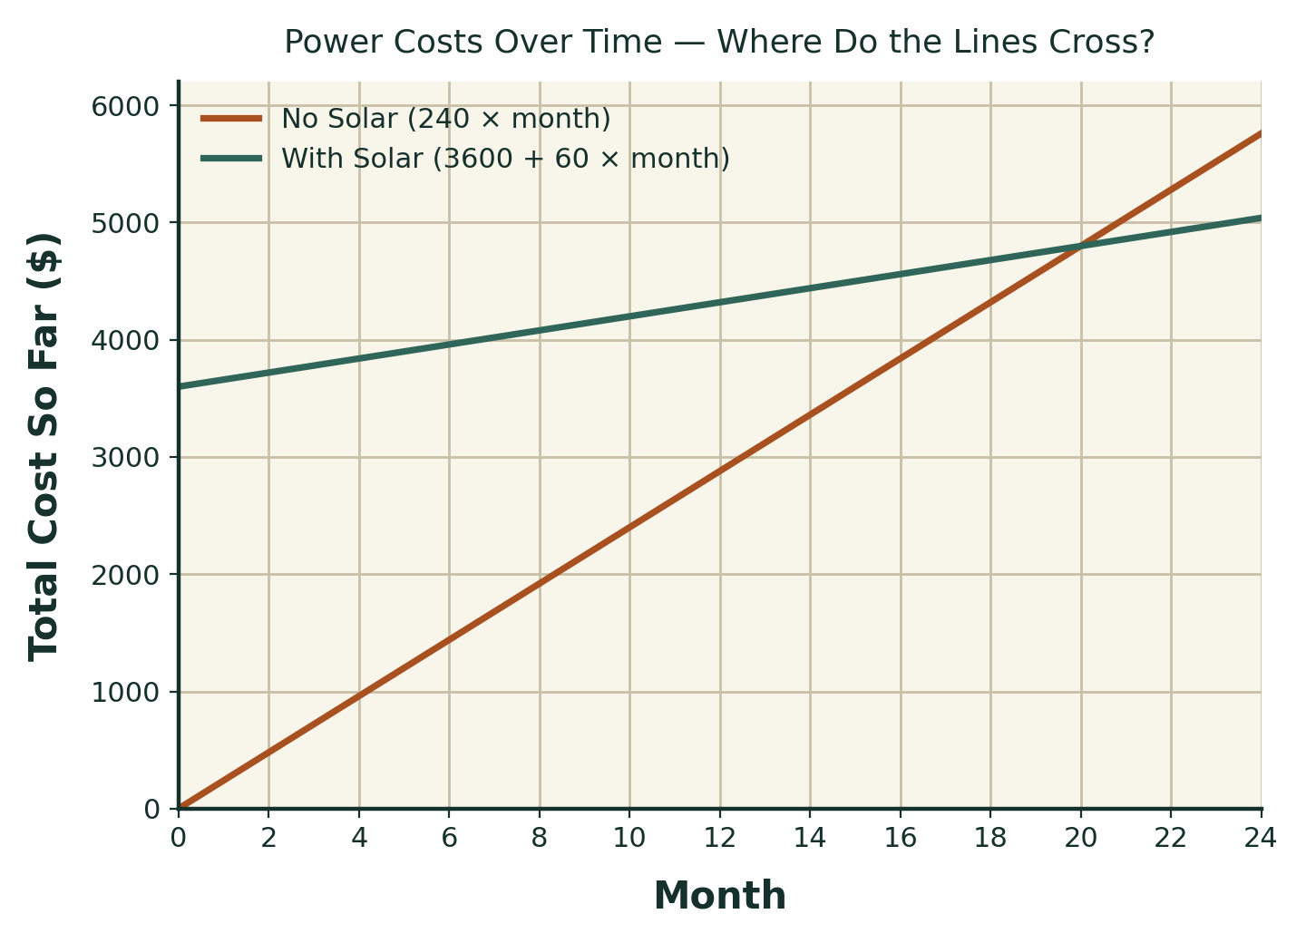
- At about which month do the lines cross?
- At that month, are the two totals about the same, or very different?
🗣️ Compare the month you found with a partner.
✅ Step 4 – Check Your Reading
Use multiplication to check a few points on each line, and confirm where they meet.

Month | No Solar (240 × month) | With Solar (3600 + 60 × month)
10 | ____ | ____
20 | ____ | ____
24 | ____ | ____

- Which month has matching (or almost matching) totals? Does it match what you read from the graph?
🧠 Make a Decision
Should the school hall install solar panels?
☐ Yes, install solar
☐ No, don't install solar
☐ It depends — explain
Explain your decision using the break-even point from your graph and table.
: ____________________________________________________________
: ____________________________________________________________
⚠️ Mission Challenge
A grant would cover half of the $3600 installation cost, bringing it down to $1800.
The monthly saving stays the same. Work out the new break-even month.

Install Cost | Monthly Saving | Break-even Month
$3600 | $180 | 20 (from your graph)
$1800 | $180 | ____
Does the grant change your recommendation? Explain.
: ____________________________________________________________
⭐ Extension Challenge
Write a rule for the total cost with solar after any number of months.
What is your rule?
🗣️ Talk with a partner before you write your rule.
My idea: __________________________________________________
🌏 Community Connection
Energy costs matter to buildings and homes across many communities, not just schools.
- Solar panels
- Diesel generators
- Water pumps or bore power
- Firewood or heating costs
What energy costs or projects matter to a building or home you know?
: ____________________________________________________________
💬 Reflection
Circle how you felt about today's mission:
😀 Confident 🙂 Mostly understood 😐 Needed some help 😕 Found it difficult
What did the graph show you that the numbers alone didn't?
: ____________________________________________________________
🌟 Bonus Challenge
Write one recommendation to the school about the solar decision, using your numbers as evidence.
: ____________________________________________________________
: ____________________________________________________________

